

Pilsley C of E Primary
RE & Collective Worship Policy
September 2026

Rationale and Ethos
Religious Education is unique in the school curriculum in that it is neither a core subject nor a Foundation subject but the 1988 Education Act states that Religious Education has equal standing in relation to core subjects of the National Curriculum in that it is compulsory for all registered pupils and embedded as part of our broad and balanced curriculum. The Purpose of RE is to encourage children to learn about and from the different religions and beliefs of the people of Derbyshire and the wider community. It encourages them to question values and traditions while exploring their own beliefs and questions of meaning. It challenges pupils to reflect, consider, analyse, interpret, evaluate and communicate their responses. RE has an important role in promoting the spiritual, moral, cultural, mental and physical development of pupils in school while preparing them for adult life, employment and life-long learning. It enables pupils to develop respect for and sensitivity to others, particularly those whose faiths and beliefs are different from their own. It promotes discernment and enables pupils to combat prejudice.

Pilsley C of E Primary School is a voluntary aided school therefore we deliver RE in line with the Derbyshire Agreed Syllabus for Religious Education 2020-2025. This is supported by the Derbyshire approved resource, ‘Understanding Christianity.’

Our School Values
We provide a high quality of education to the children of the community we serve through a safe and happy Christian environment.
P erseverence
R espect
A chievement
I ndependence
S ervice
E nthusiasm

Purpose of Collective Worship
The aim of Collective Worship is to provide the opportunity for pupils to:
• Worship God
• Reflect on values that are of a broadly Christian nature and on their own beliefs
• Develop a community spirit, a common ethos and shared values within the school vision
• Consider spiritual and moral issues
• Respond to the worship offered
• Pray or have time to think about things that matter to them
• Celebrate!

Roles and Responsibilities
RE and Collective Worship has a designated Co-ordinator and Link Governor that will regularly monitor the subject and attend CPD. The RE and Collective Worship Coordinator will ensure there is appropriate and regular INSET for all teaching staff and TAs. When using external speakers to deliver aspects of our RE and Collective Worship programme we will ensure that the School Visitors and Volunteers’ Policy is adhered to.

The Head Teacher will be responsible for:
- overall policy setting
- the depth and breadth of the RE scheme of work, ensuring that RE and Collective Worship is implemented in a way that achieves the aims and objectives of the school
- whole-school assessment and monitoring systems
- leading/facilitating staff in their provision of RE
- pupil meetings
- supporting and monitoring RE planning
- Determine the ways in which RE and Collective Worship support, enrich and extend the curriculum.
- Decide on the provision and allocation of resources.

The Subject Coordinator will be responsible for:
- keeping up to date with recent RE initiatives through appropriate training
- sharing expertise with other staff and directing them to appropriate training
- monitoring, planning and assessments
- purchasing and organising resources
- assisting colleagues with planning
- undertaking work scrutiny with the Head teacher
- collecting examples of work
- arranging the daily Collective Worship in consultation with the Headteacher and Governing body

The Class Teacher will be responsible for:
- following the school’s policy with the aim of helping pupils to improve their understanding of RE
- modelling good practice in RE skills (about and from religions)
- assessing pupil progress
- the learning environment and displaying good examples of RE understanding
- planning cross-curricular links where appropriate

The Governing Body
Regular reports are made to the governors on the progress of RE provision by the subject coordinator. Visits are made by the appointed RE governor, who then reports back to the governing body.

Legislation (Statutory Regulations and Guidance)
Link to Government Guidance

RE: statutory requirements and curriculum information from National Association of Teachers of Religious Education
The national curriculum states the legal requirement that:
'Every state-funded school must offer a curriculum which is balanced and broadly based, and which:
- promotes the spiritual, moral, cultural, mental and physical development of pupils; and
- prepares pupils at the school for the opportunities, responsibilities and experiences of later life.
All state schools ... must teach religious education ... All schools must publish their curriculum by subject and academic year online'.
(National Curriculum in England: Framework Document, DfE, September 2013, p.4)
Although there is not a National Curriculum for RE, all maintained schools must follow the National Curriculum requirements to teach a broad and balanced curriculum, which includes RE. All maintained schools therefore have a statutory duty to teach RE. Academies and free schools are contractually required through the terms of their funding agreement to make provision for the teaching of RE. Further information concerning RE in academies and free schools is given below.
The RE curriculum is determined by the local Standing Advisory Council on Religious Education (SACRE), which is responsible for producing the locally agreed syllabus for RE. Agreed Syllabuses used in schools (maintained or academy), which are not designated with a religious character must ‘reflect the fact that the religious traditions in Great Britain are in the main Christian, while taking account of the teaching and practices of the other principal religions represented in Great Britain’. Schools with a religious designation may prioritise one religion in their RE curriculum, but all schools must recognise diverse religions and systems of belief in the UK both locally and nationally.
In brief, legislation requires that:
- in maintained community, foundation or voluntary schools without a religious character, RE is taught in accordance with the local Agreed Syllabus;
- academies and free schools must teach RE within the requirements for a locally agreed syllabus, set out in section 375 (3) of the Education Act 1996 and paragraph (5) of Schedule 19 to the School Standards and Framework Act 1998. The requirements are that a syllabus must ‘reflect the fact that the religious traditions in Great Britain are, in the main, Christian while taking account of the teaching and practices of the other principal religions represented in Great Britain’;
- for foundation and voluntary controlled schools with a religious character, RE must be taught according to the Agreed Syllabus unless, parents request RE in accordance with the trust deed of the school; and
- in voluntary aided schools RE must be taught in accordance with the trust deed.
RE must be included in the curriculum for all registered pupils, including all pupils in reception classes and sixth form, but excluding:
- pupils in nursery schools or nursery classes in primary schools;
- any person aged nineteen or above for whom further education is being provided at school; and
- any person over compulsory school age who is receiving part-time education.

Entitlement
We expect and encourage all children to attend R.E. lessons. However, any parent can request permission for their child to be excused from attending RE lessons and the school will make alternative arrangements for the supervision of the child during the period concerned. Parents do not have to explain or give reasons for this. This complies with the 1944 Education Act and was restated in the 1988 Education Reform Act.

Collective Worship
All maintained schools provide a daily act of Collective Worship (apart from those children who may be withdrawn at their parent’s request).

Collective Worship must be wholly or mainly of a broadly Christian character. The precise nature will depend on the family background, ages and abilities of all the pupils. However, if it is inappropriate for some, or all of the pupils to take part in Collective Worship, the Headteacher may apply to the Standing Advisory Council on Religious Education (SACRE) for a determination to have this requirement lifted. Collective Worship in foundation schools with a religious character, and voluntary schools, will be in accordance with the school’s trust deed. Where provision is not made by a trust deed, the worship should be in accordance with Derby Diocese guidelines.

Curriculum Design - RE
The amount of time dedicated to the R.E. curriculum follows the recommendations set down in the Agreed Syllabus for Derbyshire and overall it should work out as:

Early Years Foundation Stage: 36 hours of RE integrated into Learning, eg, part of Personal, Social and Emotional Development and Understanding of the World.
Key Stage 1: 36 hours of tuition per year
Key Stage 2: 45 hours of tuition per year.

Intent

Religious education is a core component within our curriculum. It encourages children to develop a better understanding of themselves, their beliefs and morals. RE has deep connections with children’s SMSC (spiritual moral, social and cultural) development. SMSC is embedded across the curriculum at Pilsley but comes to the forefront in RE lessons. The RE curriculum at Pilsley enables the children to explore the beliefs of others and to reflect on their own beliefs in the process. Students can engage with controversial issues and learn to disagree respectfully with each other. We seek to inspire in our children an awareness, respect and tolerance for others who hold different beliefs and opinions to their own. RE lessons aspire to promote the children’s interest in how people choose to live their lives and understand why people make those choices. In our 21st century, multi-cultural society, RE lessons provide essential skills for being part of a positive community. RE teaches children to ask thoughtful questions, make informed judgements, reflect and connect.

At the core of our RE curriculum is the Derbyshire and Derby City Agreed Syllabus, this is personalised for our children through the Understanding Christianity resource and our school PRAISE vision. This vision is fully implemented through daily acts of worship as well as being brought into our class learning and life around school continually. These key values are:

Perseverance,Respect, Achievement, Independence, Service and Enthusiasm
Implementation

RE is taught in class groups in regular weekly sessions throughout the year, so that children can revisit and build on their learning. This structure allows children to develop a depth of understanding as well as enabling them to retain the knowledge through consolidation and progression.

At Pilsley, we use the Derbyshire and Derby City Agreed Syllabus. The principal aim of this syllabus is:

“to engage pupils in systematic enquiry into significant human questions which religion and worldviews address, so that they can develop the understanding and skills needed to appreciate and appraise varied responses to these questions, as well as develop responses of their own.”

This syllabus provides RE objectives and key questions that are academically challenging and personally inspiring. The units of work provoke challenging questions about meaning and purpose in life, beliefs about God, ultimate reality, issues or right and wrong and what it means to be human.

Alongside this syllabus, Pilsley also uses the compatible Understanding Christianity scheme of work. As a Church of England school we have a specific focus on Christianity which comes into Collective Worship every day and our RE lessons. Use of this resource has raised standards and sets high expectations for learning in RE. The Understanding Christianity resource covers eight core concepts at the heart of mainstream Christian belief. Their building blocks set out clear progression from EYFS to KS3.
The core concepts are:
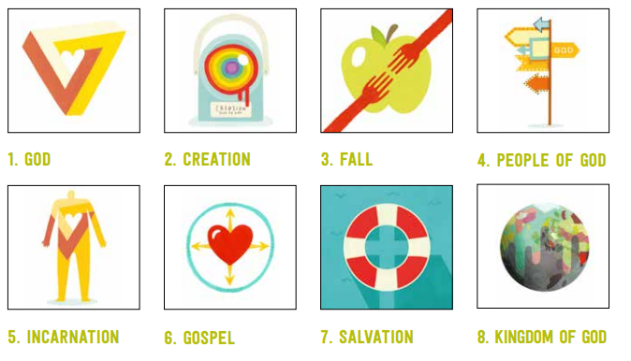

Progression is ensured by the effective assessment of impact. This curriculum prepares our children for their future education and life beyond. The progression of concepts is shown here:

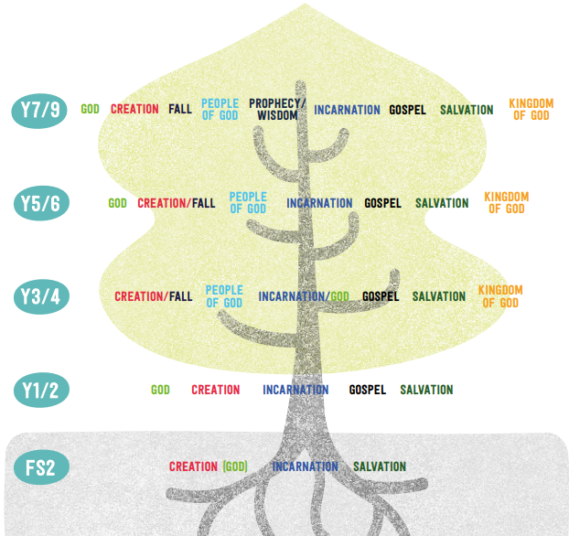

Understanding Christianity’s approach to teaching about Christianity builds up pupils’ encounters
with biblical concepts through texts, placing the texts and concepts within the wider Bible story. Each unit addresses a concept, through some key questions, exploring core Bible texts, their impact for Christians, and possible implications for pupils. Each unit incorporates the three elements below:

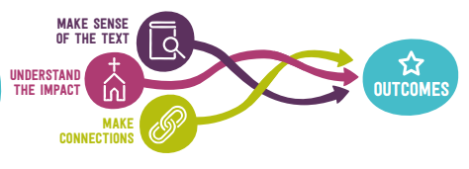

Impact
Each child has an RE book which follows them up through school. Children are encouraged to look back at previous work that links to their current learning. This also allows teachers to build on prior learning and make connections. Every RE unit has a key question that is introduced in the first lesson. By the end of the unit, children are expected to respond to the question in a range of ways; this could be a piece of extended writing, artwork or a class debate. RE lessons are planned in a way that children receive continuous feedback from their teacher and peers through discussion and sharing.

Assessment for Learning is embedded in practice, with both staff and children continually reflecting on their learning, allowing for support and extension in both knowledge and skills. In every area of school life our pupils are given very high expectations in their behaviour. We have a successful rewards and consequences system, which progresses throughout the school to maintain effectiveness.
Curriculum Design – Collective Worship
Intent
At Pilsley C of E Primary School our aim is for collective worship to reflect the traditions of the Church of England, enabling children to develop an understanding of Anglican worship and practice and embed this in their daily lives. Collective worship sessions celebrate our school PRAISE values: Perseverance, Respect, Achievement, Independence, Service and Enthusiasm. These values thread through all aspects of school life. Through considered collective worship sessions, we strive to nurture children’s spiritual education. We encourage them to make time to reflect and wonder, celebrate and respond to God; to consider their opinions, actions and feelings and those of others. We ask them to think about themselves as individuals and how they can impact on their community and on the wider world; recognising the positive contributions we can all make. At Pilsley, fostering a sense of community is central to our aims; encouraging the children in the spirit of Service to care for one another, the school and wider community; celebrating difference and diversity.

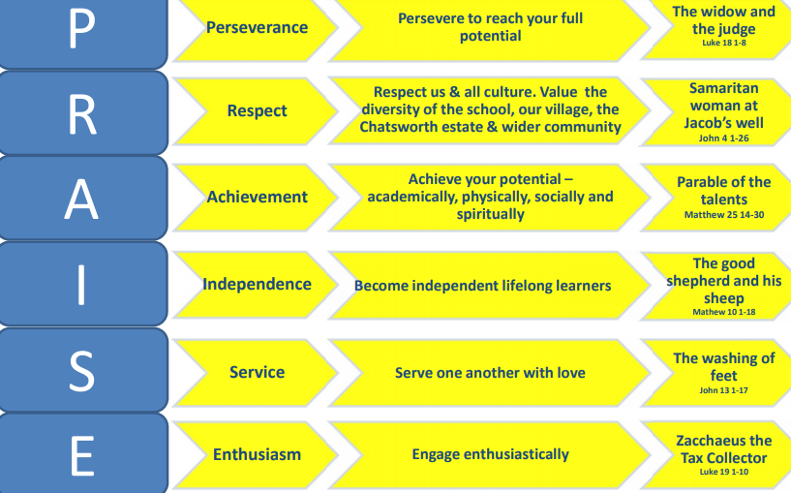

Implementation
Our daily act of Collective Worship is led by teachers, pupils and members of the local church. Children have regular opportunities to demonstrate the values of Enthusiasm and Service by participating in collective worship and to helping to plan collective worship and church services as part of their class or the PRAISE team. Collective worship sessions are planned to be invitational, reflective and engaging. Provision is considered to ensure all pupils to benefit without compromising their own beliefs. We use the Imaginor 'Roots and Fruits' materials to ensure worship sessions are rooted in the bible and reflect the Church of England Liturgical Calendar. Collective worship sessions follow a framework of Welcome, Learning, Reflecting and Responding. Prayers and singing are key elements of worship sessions and link to the worship theme. Sessions include quotes and questions to encourage deeper thinking, photographs and posters, stories, poems and art, to prompt response and enquiry, prayers and guided reflections. Fruits from the Roots – provides ideas to develop the theme of the worship throughout the week beyond collective worship sessions.

Each half term Collective worship sessions are linked by a specific Christian value. Themes include: Generosity, Compassion, Courage, Forgiveness, Friendship, Respect, Thankfulness, Trust, Perseverance, Justice, Service and Truthfulness. To support and extend our thinking about each value, we use resources from Church of England Schools Worship Workshop and the Cornerstones Assembly Programme. This enables our worship programme to explore British values, environmental and topical issues and to celebrate significant figures and their contributions to human thought and development which illustrate the theme. At the end of each term, we hold a service in a local church. Parents are and the wider community invited to this and also to our Celebration events throughout the year.

In line with the Church of England Church Schools Guidance, we aim to provide worship sessions which give pupils and school staff the opportunity to:
- Engage in an act of community.
- Express praise and thanksgiving to God.
- Be still and reflect.
- Explore the big questions of life and respond to national events.
- Foster respect and deepen spiritual awareness.
- Reflect on the character of God and on the teachings of Christ.
- Affirm Christian values and attitudes.
- Share each other's joys and challenges.
- Celebrate special times in the Christian calendar.

Impact
At Pilsley in all areas of school life we set high expectations about pupil’s behaviour and we encourage children to conduct themselves in a manner that reflects our school values at all times. How children interact with each other and live out these values throughout the school day, coupled with their responses and level of engagement, provides a good insight into the impact of collective worship sessions at Pilsley.
In order to evaluate the quality and effectiveness of collective worship, pupil’s feelings about sessions are gauged through use of pupil feedback. This ensures worship can reflect children’s thoughts and ideas. Children are included in planning sessions to ensure collective worship remains interesting and relevant to them. Feedback from staff and visitors also feeds into the planning cycle to encompass their thoughts and contributions.

Collective Worship (CW) Policy

Aims and Purpose of Collective Worship
At Pilsley C of E Primary School, Collective Worship is a central and valued part of our school day. It provides a unique opportunity for the whole school community to come together to reflect, worship, and celebrate. Our acts of worship are rooted in Christian teachings, values, and the school’s Christian vision, while remaining inclusive, invitational, and inspiring to all, regardless of faith background.
The aims of Collective Worship are to:
- Provide the opportunity for all pupils and staff to:
  - Engage in an act of community and unity.
  - Express praise and thanksgiving to God.
  - Reflect on the character of God and the teachings of Jesus.
  - Be still and reflect on spiritual and moral issues.
  - Explore the big questions of life and respond to national and global events.
  - Foster respect, deepen spiritual awareness, and affirm Christian values and attitudes.
  - Share each other’s joys and challenges.
  - Celebrate special times in the Christian calendar and the life of the school.
We aim for our worship to inspire — offering peace, motivation, comfort, or joy — and to encourage children to consider their own behaviour, choices, and beliefs, while also developing respect for the faiths and beliefs of others.

Legal Requirements and Right to Withdraw
In line with the 1988 Education Reform Act, all maintained schools are required to provide daily Collective Worship. As a Voluntary Aided Church of England school, our acts of worship are wholly or mainly of a broadly Christian character, reflecting our foundation and trust deed.
Parents have the legal right to withdraw their child from Collective Worship, wholly or partly, without providing a reason. If a parent wishes to do so, we invite a conversation to discuss:
- Which aspects of worship they object to.
- The practical implications for their child during withdrawal.
- Whether advance notice of themes is required.
Alternative arrangements will be made to supervise any child withdrawn from worship.

Organisation and Implementation
Collective Worship is held daily for approximately 20 minutes. The current structure includes:
- Monday: Singing Worship
- Tuesday: Whole-school Worship
- Wednesday: Whole-school Worship
- Thursday: Whole-school Worship
- Friday: Celebration Worship

Worship may be led by staff, pupils, clergy (e.g., the local vicar), or visitors such as MAST. Worship is also sometimes held outdoors or at local churches.
We follow a 4-part structure to help children engage meaningfully:
- Gathering – Welcoming and setting the tone.
- Engaging – Exploring the theme, often through story, Scripture, or reflection.
- Responding – Opportunity to reflect, pray, or act.
- Sending – A shared message or blessing to conclude and return to class.

We also use consistent half-termly themes, songs, images, and gathering words to support understanding and participation across all ages
.
Children are invited (but never compelled) to participate in prayer, reflection, or response. We use invitational language and a variety of approaches to ensure accessibility and relevance.

Inclusivity and Engagement
Our Collective Worship is:
- Inclusive – open and relevant to pupils of all faiths or none, using respectful language and accessible activities.
- Invitational – participation is encouraged, not enforced.
- Inspiring – designed to spark curiosity, emotional response, and deeper thinking.

We also incorporate opportunities for children to prepare and share prayers, reflections, or creative responses. Visuals, artefacts, stillness, storytelling, and music are used to enrich the worship experience.

Impact and Reflection
Worship at Pilsley is a vital part of spiritual development. It enhances our school’s ethos, builds a sense of belonging, and provides moments of wonder, hope, gratitude, and compassion. Pupils are encouraged to reflect on how worship impacts their daily lives and relationships with others.

Regular review and pupil voice (e.g., through worship teams or feedback) ensure that our worship continues to meet the spiritual needs of our community and reflects our vision and values.

Equal Opportunities, Inclusion, Special Educational Needs and Disabilities (SEND)
Schools have a responsibility to provide a broad and balanced curriculum for all pupils.
We aim to encourage all pupils to reach their full potential through the provision of varied opportunities and differentiated lessons. Through the teaching of RE and Collective Worship we aim to develop awareness of ethnic, cultural and economic diversity of human society and to foster positive attitudes to all people. Care is taken when selecting source material that a range of perspectives and viewpoints are represented including those of men and women from different racial, national and religious groups. Care is also taken that societies are not just represented from the British perspective but also from their own. The importance of the pupils’ own cultural background is recognised as a resource which may give an alternative perspective on events of the past as well as the present. The RE and Collective Worship co-ordinator will liaise with the SENCO to ensure that the children with SEN achieve their full potential in lessons and worship.

Educational Visits
We aim to provide strong foundations for children’s development of religious knowledge, skills and understanding, by making best use of primary and secondary resources in our local area. Educational visits to places of RE value will be used to support the pupils work. The learning process will be based on direct experience and practical activities and will take into account the pupils own interests, experiences and activities.

Safeguarding
In cases where there is a safeguarding risk, school safeguarding policy in relation to Keeping Children Safe in Education 2018 will be followed. All external contributors will be informed of our safeguarding policy prior to working with the children. We also recognise there may be disclosures that aren’t safeguarding issues, but opportunities to support the child. If this occurs staff may refer to or suggest appropriate local or national support services or information for pupils and/or their families. If a question raises potential safeguarding concerns, staff should respond in a way that will allow them time to seek advice from the Safeguarding Lead or Deputy Safeguarding Lead by replying with for instance: ‘That is a really interesting question and I need time to think because I want to give you a proper answer.’
Links to Other School Policies
This Policy compliments the following policies: Child protection/safeguarding; Extremism; Anti-Bullying; Attendance; Behaviour; Inclusion; School Visitors and Volunteers. RE also offers a valuable contribution to other curriculum aims, in particular SMSC and the promotion of British Values, Equal Opportunities.

Engaging stakeholders
This policy has been produced through engagement with the Local Authority, Governors and Teaching Staff. We will communicate with parents and carers through Pilsley’s school website, Pilsley’s Facebook Page as well as letters to parents and discussions during parent meetings. As a school we feel it is important to keep parents informed about what we will be discussing so that they can support their child’s learning and answer any questions they may have at home. Outside visitors are used to enhance the curriculum of RE and Collective Worship. Visitors are required to follow the ethos of this policy in line with Pilsley’s School Visitors and Volunteers Policy.

RE & Collective Worship Policy review date
This policy will be reviewed in June 2027 by the RE & Collective Worship Coordinator. This will ensure that the policy continues to meet the needs of pupils, staff and parents and that it is in line with current Department for Education advice and guidance.

