
Pilsley Church of England Primary School
Collective Worship Policy
December 2025
Pilsley C of E Primary School Motto:


“From tiny seeds, great things grow”
(Inspired by the Parable of the Mustard Seed Matthew 31 – 32)

Our School Values
Our PRAISE values—Perseverance, Respect, Achievement, Independence, Service, Enthusiasm—guide every aspect of school life and underpin all collective worship.

Purpose of Collective Worship
Collective Worship at Pilsley C of E Primary School aims to give every child the opportunity to:
- Worship God within a welcoming Christian environment
- Reflect on Christian teaching, their own beliefs, and their personal spiritual journey
- Build a sense of community, belonging, and shared values
- Consider spiritual, moral and ethical themes
- Respond through prayer, reflection, stillness or song
- Celebrate together as a school family
All maintained schools provide a daily act of collective worship. At Pilsley, worship is wholly or mainly of a broadly Christian character and reflects the traditions of the Church of England.

Curriculum Design – Collective Worship
Intent
At Pilsley, our worship reflects the richness of Anglican tradition and supports children in embedding Christian values in daily life.
Worship encourages children to:
- Reflect and wonder
- Explore big questions
- Consider their role in school, the community, and the wider world
- Recognise how small actions can grow into great things, linking to our Christian vision and motto
Our PRAISE values and school vision weave through all worship sessions, inspiring the children to foster a sense of community, which is central to our aims; encouraging the children in the spirit of service to care for one another, the school and the wider world and community; celebrating difference and diversity.
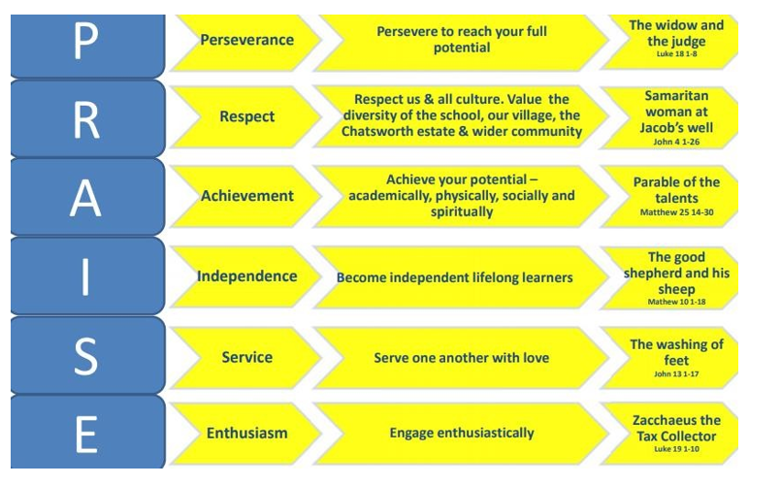

Implementation
Daily worship includes familiar, consistent elements to create rhythm and pattern:
- Opening words and responses
- Lighting the candles in the name of God the Father, Son and Holy Spirit
- Time for exploration, response, reflection, song, and prayer
Children are active participants throughout worship:
- Joining in call-and-response
- Taking turns to lead prayers and readings
- Contributing through the Praise Team, who help plan worship, write prayers and reflect pupil voice.
Worship is primarily planned using Imaginor’s Roots and Fruits materials, ensuring sessions:
- Are rooted in the Bible
- Follow the Church of England liturgical calendar
- Focus each half term on a specific Christian value (e.g. Generosity, Courage, Service, Thankfulness)
Worship is enriched by:
- Resources from CofE Schools Worship Workshop and Cornerstones
- Acknowledgement of special events and awareness days.
- Clergy involvement, church links and celebratory end-of-term services
- Themes that connect meaningfully to children’s lives
Provision is planned to be inclusive, invitational and reflective so all pupils benefit without compromising personal beliefs.

Impact
The impact of worship is seen through:
- How pupils demonstrate and articulate our PRAISE values
- Their engagement, behaviour and interactions throughout the school day
- Their ability to reflect, ask questions and express spiritual awareness
Regular feedback from pupils, staff, clergy and visitors informs ongoing development. Children contribute to planning, ensuring worship remains relevant and meaningful.

Equal Opportunities and Inclusion
Worship is accessible to all pupils, including those with SEND.
We ensure:
- A wide range of perspectives and cultures are represented
- Resources are chosen thoughtfully
- All children are supported to reach their full potential
The RE/Collective Worship lead works closely with the SENCO and advisory teachers to support inclusion.

Educational Visits
Where relevant, visits to local places of worship or significance in RE deepen children’s understanding through direct experience.

Safeguarding
All worship follows the school’s safeguarding policy in line with Keeping Children Safe in Education.
Visitors are informed of safeguarding requirements. Staff respond sensitively to questions that may raise pastoral or safeguarding concerns.

Links to Other Policies
This policy complements:
- Safeguarding / Child Protection
- Behaviour
- Inclusion
- Attendance
- Anti-Bullying
- Extremism
- Visitors & Volunteers
- SMSC and British Values

Engaging Stakeholders
The policy has been developed with the Local Authority, governors and staff.
We communicate worship themes and RE learning with families through:
- The school website
- Facebook
- Letters and newsletters
- Parent meetings
Visitors enhance Collective Worship and RE and follow the ethos of this policy.
Collective Worship Policy Review Date
This policy will be reviewed in Dec 2026 by the Collective Worship Coordinator. This will ensure that the policy meets the needs of pupils, staff and parents and that it is in line with the current DFE advice and guidance.

