Class 3 Snow Day Activities January 2025
Good morning Year 3 and Year 4!
We are sorry we cannot be together today but we hope you get the chance to have some fun in the snow. Here are some learning suggestions for you.
- English
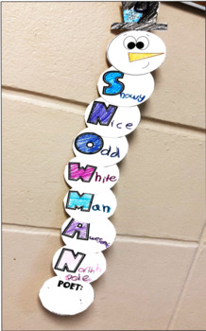
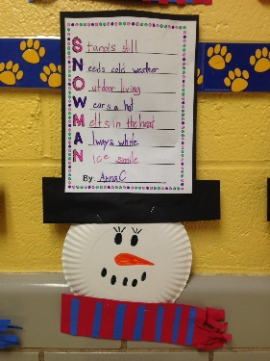
Create an acrostic poem about SNOWMAN
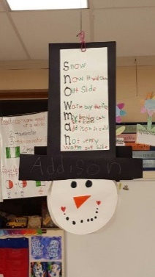
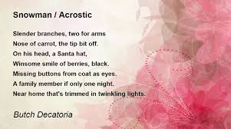
- Reading
Snuggle up with a book. Get cosy and enjoy reading for pleasure 📖
- Maths
- Practise your times tables. You could use Hit the Button or you could write them out on paper.
https://www.topmarks.co.uk/maths-games/hit-the-button
- Look at the changes in temperature throughout the day. What do you notice?
- Science- Snowball investigation
Make 3 similar sized snowballs. Wrap them in 3 different materials, keep them in the same place and see which melts slowest/quickest.
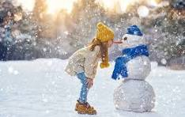
- Topic- research and write down 3 facts about volcanoes (ask an adult for guidance if using the internet).
Have a lovely day, stay safe and warm!
Mrs Thompson

