MFL:
French- L’ancienne histoire de la Grande Bretagne. Les animaux.

Chronology of Roman Empire
PSHE:
Difference and diversity
Bullying matters

Science

Living things; Carnivores, herbivores and omnivores; Human diet; Human nutrition and food groups; Fatty foods; Seasonal changes in animals' diets; Human skeleton; Joints; Muscles; Skeleton types – endoskeletons and exoskeletons; Working scientifically – Identifying and classifying, Observing changes over time, Comparative test, Pattern seeking, Research

Music:
Hear it, play it! exploring rhythmic patterns.
Singing/performance

C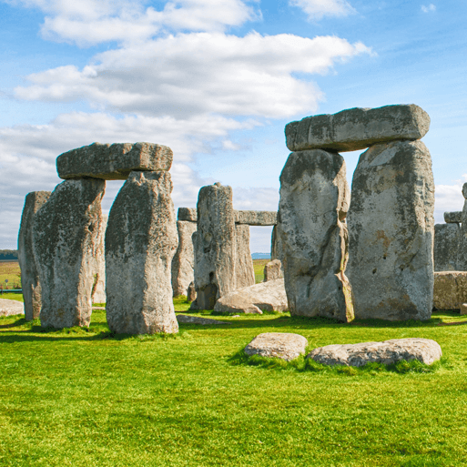
Computing:
Creating media- desktop publishing.
Computing systems and networks-Connecting computers.

Art and Design Technology:
Colour theory, cave painting, Bell Beaker culture; Sketching; Clay techniques; Making Bell Beaker-style pots.
D+T Food groups; Eatwell guide; Methods of cooking; Cooking appliances; Hygiene rules; Making taco fillings

Through the Ages
History:
Prehistory from the Stone Age to the Iron Age.
Chronology, everyday life in Stone Age, tools, settlements, monuments, everyday life in Bronze age, Beaker folk,
Metalworking, wealth and power, Iron Age cause and effect, boom in farming, inventions, Iron Age hoards, homes and hillforts.
PE

Games, Outdoor Adventurous activities, Gymnastics, Dance

R.E:
What can we learn from religions about deciding what is right and wrong? Christians, Jewish people and non-religious responses (e.g. Humanist)
Incarnation- what is the Trinity?

Maths:
Place value-numbers to 10 000,
addition and subtraction,
multiplication and division,
time,
Problem solving
English:
Class Text: Stig of the Dump by Clive King
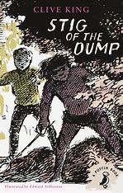
Genres:
Historical Narratives
Instructions
Cinquains
Chronological reports
Recounts

