MFL:
L’ancienne historie de la Grande-Bretagne.
Verbs- ‘to be’, ‘to have’ and ’to live’.
Les animaux

Chronology of Roman Empire
PSHE:
Changes
Drug education

Science

Grouping and classifying part 2- study the plant and animal kingdoms and use and create classification keys to identify living things.
Electrical circuits and conductors- sources of electricity; Electrical devices; Electrical components; Series circuits; Complete and incomplete circuits; Conductivity; Conductors and insulators.

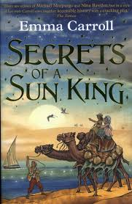

Music:
Drumming
Singing/performance

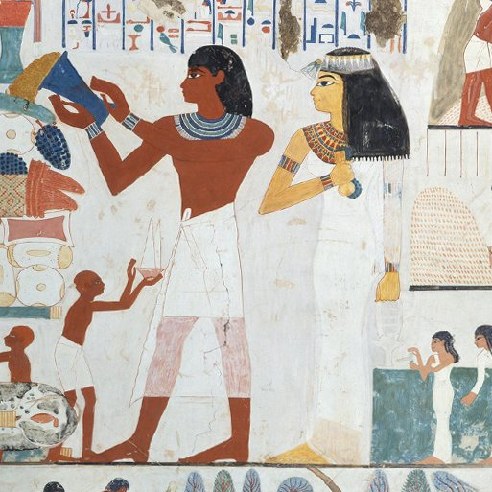

Ancient Civilisations
PE

Games, Athletics, Swimming, Gymnastics, Dance.

R.E:
What does it mean to be a Christian in Britain today?
What does it mean to be a Hindu in Britain today?
Why do some people believe that life is like a journey?
Maths:

Fractions, Length, Mass, Volume, Decimals,
Money, Perimeter, Area, Lines and shapes, Position and movement,
Problem solving
Art and Design Technology:

Figure drawing; Statues, statuettes and figurines; Sculptures from ancient civilisations; Clay work and sculpting.
Features of Islamic art; Motifs and patterns; High and low relief clay sculpture
Tomb builders-creating simple machines/ pulleys and levers.
Computing:
Creating Media- photo editing
Programming-repetition in games

English:
Class Text: Secrets of a Sun King by Emma Carroll

Genres:
Instructional texts
Film narrative
Stories from other cultures
Free verse poetry
History:

The rise of Ancient Sumer, city states and hierarchy.
Exploring Ancient Egypt- city life, hierarchy, role of the Pharoah, tales from the tombs.
Investigating the Indus Valley.

